**DATATYPES:**

**DATATYPE IS AN ATTRIBUTE WHICH SPECIFIES WHAT TYPE OF DATA IS STORED INTO A COLUMN.ORACLE SUPPORTS THE FOLLOWING DATATYPES ARE**

**1) NUMERIC DATATYPES**

**2) CHARACTER DATATYPES/ STRING DATATYES**

**3) LONG DATATYPE**

**4) DATE DATATYPES**

**5) RAW & LONG RAW DATATYPES**

**6) LOB DATATYPES(LARGE OBJECTS DATATYPES)**

**1) NUMERIC DATATYPES:**

**i) INT**

**ii) NUMBER(P,S)**

**INT: STORING INTEGER FORMAT VALUES ONLY.**

**INT = NUMBER(38)**

**NOTE: WHEN WE USE “INT” DATATYPE ON COLUMN AT THE TIME OF TABLE CREATION THEN INTERNALLY ORACLE SERVER WILL CONVERT INTO “NUMBER” DATATYPE WITH MAXIMUM SIZE IS 38 DIGITS.**

**NUMBER(P,S): STORING BOTH INTEGER & FLOAT FORMAT VALUES.** **HERE THIS DATATYPE IS HAVING FOLLOWING TWO ARGUMENTS ARE PRECISION(P),SCALE(S).**

**WHEN WE USE ----> NUMBER(P)------> STORE INTEGER VALUES**

**WHEN WE USE ----> NUMBER(P,S)----> STORE FLOAT VALUES**

**PRECISION(P):**

**> COUNTING ALL DIGITS INCLUDING LEFT & RIGHT SIDES OF GIVEN FLOAT EXPRESSION.**

**Ex: 25.12**

**PRECISION = 4**

**Ex: 856.45**

**PRECISION = 5**

**Ex: 9999.99**

**PRECISION = 6**

**SCALE(S):**

**> COUNTING ONLY RIGHT DIGITS OF A FLOAT EXPRESSION.**

**Ex: 25.12**

**SCALE = 2**

**PRECISION = 4**

**Ex:**

**7456.123**

**SCALE = 3**

**PRECISION = 7**

**2) CHARACTER DATATYPES: STORING "STRING" FORMAT DATA ONLY.IN DATABASE STRING IS REPRESENT WITH SINGLE QUOTES ' <STRING> '.CHARACTER DATATYPES ARE STORING TWO TYPES STRING FORMAT DATA.THOSE ARE**

1. **CHARACTERS ONLY STRING DATA ii) ALPHANUMERIC STRING DATA.**

**Ex:**

**CHARACTER DATATYPES**

**|**

**< STRING FORMAT DATA >**

**|**

**| |**

**CHARACTERS ONLY ALPHANUMERIC CHAR's**

**STRING DATA STRING DATA**

**[ A - Z (or) a - z ] [ A - Z (or) a – z & 0 - 9 &**

**@,#,$,%,&,_,.......etc ]**

**Ex: 'SAI', 'ALLEN ',......etc Ex: ' sai123@gmail.com ',....etc**

**NOTE: CHARACTER DATATYPES ARE AGAIN CLASSIFIED INTO TWO CATEGORIES THOSE ARE**

**1) NON - UNICODE DATATYPES:SUPPORTING TO STORE LOCALIZED DATA( ONLY ENGLISH LANGUAGE)THESE ARE AGAIN TWO TYPES.**

**1) CHAR(SIZE):**

**- IT IS A FIXED LENGTH DATATYPE(STATIC).**

**- WILL STORE NON-UNICODE CHAR's IN THE FORM OF 1 CHAR = 1 BYTE.**

**- MAXIMUM SIZE OF CHAR DATATYPE IS 2000 BYTES(2000 CHAR's).**

**2) VARCHAR2(SIZE):**

**- IT IS A VARIBALE LENGTH DATATYPE(DYNAMIC).**

**- WILL STORE NON-UNICODE CHAR's IN THE FORM OF 1 CHAR = 1 BYTE.**

**- MAXIMUM SIZE OF VARCHAR2 DATATYE IS 4000 BYTES(4000 CHAR's).**

**DIFFERENCES BETWEEN FIXED LENGTH DATATYPES AND VARIABLE LENGTH DATATYPES:**

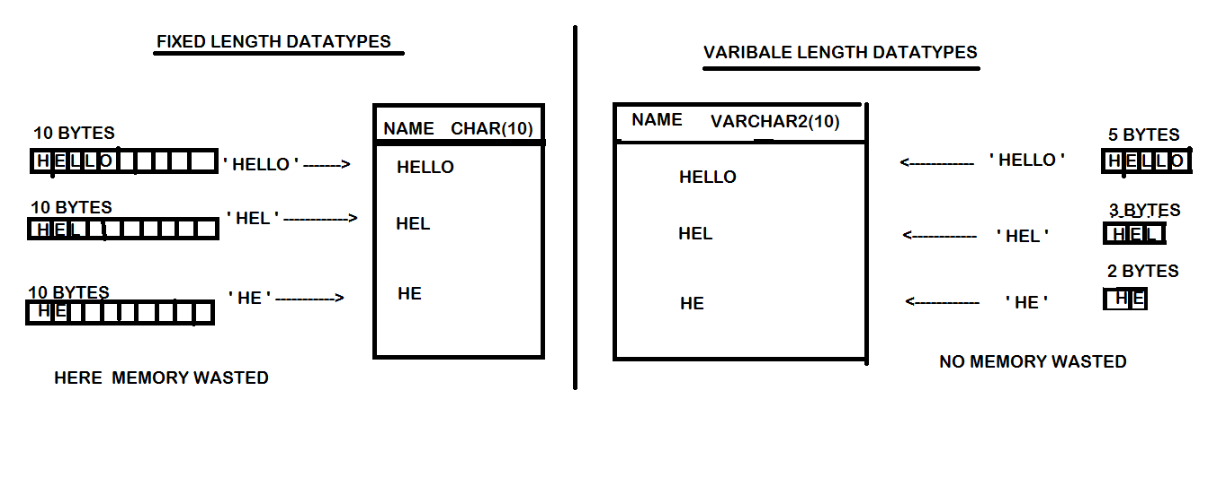

**2) UNICODE DATATYPES: THESE DATATYPES ARE STORING "GLOBALIZED DATA" SUPPORTING "ALL NATIONAL LANGUAGES".THESE ARE TWO TYPES,**

**1) NCHAR(SIZE):**

**- IT IS FIXED LENGTH DATATYPE(STATIC).**

**- WILL STORE UNICODE CHAR's (ALL NATIONAL LANG's) IN THE FORM OF**

**1 CHAR = 1 BYTE.**

**- MAXIMUM SIZE OF NCHAR DATATYE IS 2000 BYTES(2000 CHAR's).**

**2) NVARCHAR2(SIZE):**

**- IT IS A VARIBALE LENGTH DATATYPE(DYNAMIC).**

**- WILL STORE UNICODE CHAR's IN THE FORM OF 1 CHAR = 1 BYTE.**

**- MAXIMUM SIZE OF nVARCHAR2 DATATYE IS 4000 BYTES(4000 CHAR's).**

**3) LONG:**

**- IT IS VARIBALE LENGTH DATATYPE(DYNAMIC).**

**- WILL STORE NON-UNICODE & UNICODE CHAR's IN THE FORM OF 1 CHAR = 1BYTE.**

**- MAXIMUM SIZE OF LONG DATATYE IS 2GB.**

**4) DATE DATATYPES:**

**- STORING DATE AND TIME INFORMATION OF A PARTICULAR DAY.**

**- RANGE OF DATE DATATYPES IS FROM "01-JAN-4712 BC " TO "31-DEC-9999 AD ".**

**i) DATE: STORING DATE & TIME INFORMATION BUT TIME IS OPTIONAL.IF NOT ENTERED TIME BY USER THEN ORACLE "12:00:00AM".DEFAULT FORMAT OF DATE DATATYPE IS 'DD-MON-YYYY / YY HH: MI: SS '.IT OCCUPIED 7 BYTES OF MEMORY (FIXED MEMORY).**

**ii) TIMESTAMP: STORING DATE & TIME INFORMATION ALONG WITH MILLISECONDS.DEFAULT FORMAT OF DATE DATATYPE IS 'DD-MON-YYYY / YY HH: MI: SS.MS'. IT OCCUPIED 11 BYTES OF MEMORY (FIXED MEMORY).**

**5) RAW & LONG RAW: STORING IMAGE / AUDIO / VIDEO FILES IN THE FORM OF 010010101001 BINARY FORMAT.THE MAXIMUM SIZE OF RAW DATATYPE IS 2000 BYTES AND LONG RAW SIZE IS 2 GB.**

**6) LOB DATATYPES (LARGE OBJECTS):**

**i) BLOB (BINARY LARGE OBJECT): STORING IMAGE / AUDIO / VIDEO FILES IN THE FORM 010010101001 BINARY FORMAT.THE MAXIMUM SIZE IS 4GB.**

**ii) CLOB (CHARACTER LARGE OBJECT): STORING NON-UNICODE CHARACTERS.THE MAXIMUM SIZE IS 4GB.**

**iii)N CLOB(NATIONAL CHARACTERS LARGE OBJECT):STORING UNICODE CHARACTERS.THE MAXIMUM SIZE IS 4GB.**

**NOTE:**

**> CHAR IS UPTO 2000 BYTES > NCHAR IS UPTO 2000 BYTES**

**> VARCHAR2 IS UPTO 4000 BYTES >NVARCHAR2 IS UPTO 4000 BYTES**

**> CLOB IS UPTO 4 GB >NCLOB IS UPTO 4 GB**

**> RAW IS UPTO 2000 BYTES > LONG RAW IS UPTO 2GB**

**> BLOB IS UPTO 4 GB.**